**Course-End Project: Crime Analysis**

1. Overall Crime Statistics Dashboard:
   1. For personnel and resource management, the department needs to understand the count and types of crimes reported across the city. Mark the locations on a geo-map highlighting the locations with recent criminal history.
   2. Identify the most common criminal incidents reported.
   3. In this introductory dashboard, include a live crime feed to exhibit the total number of crimes reported to date for the current year and the most recently reported crime with their time and locations.

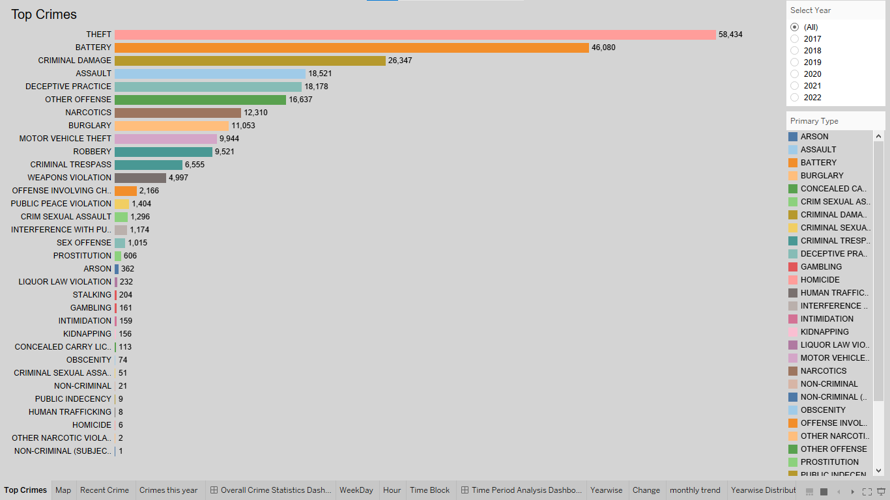

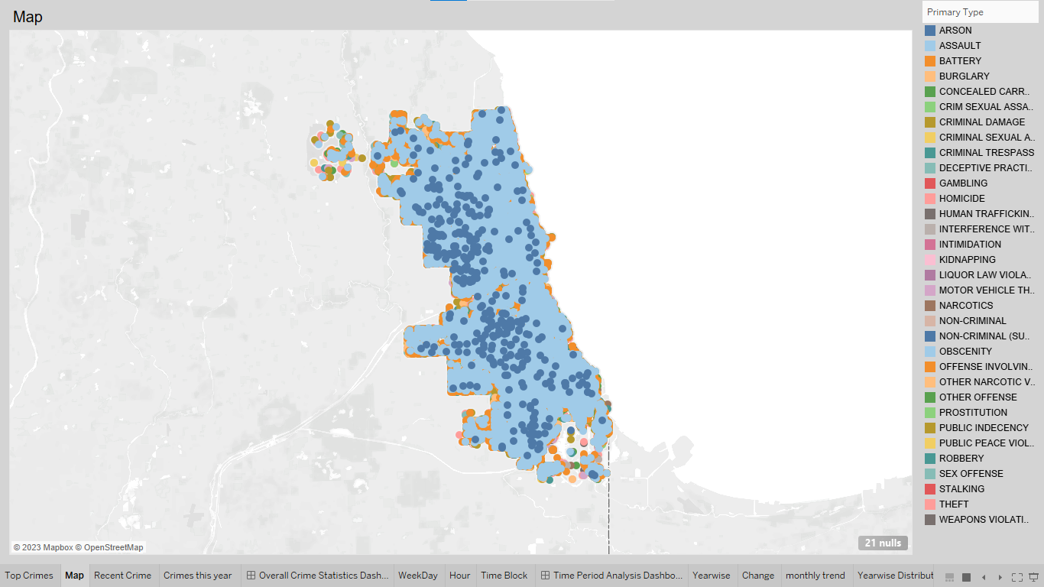

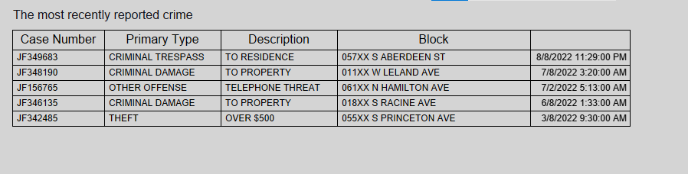

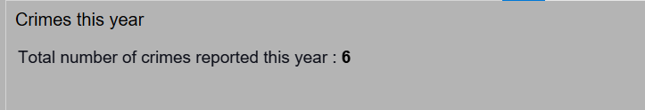

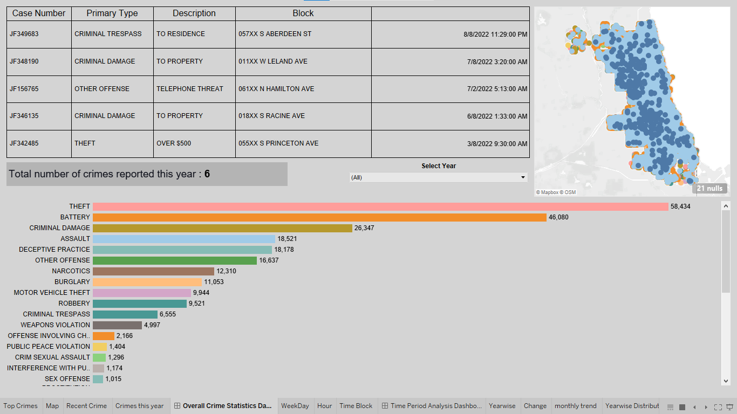

1. Time Period Analysis Dashboard:

Along with locations, the study of crime statistics across time statistics is also crucial for understanding the patterns and planning those preventive strategies.

1. Study distribution count of crime incidents across different time periods such as day of the week or hour.
2. Further explore the percentage of incident reporting for several time blocks (afternoon, evening, early morning, etc.).

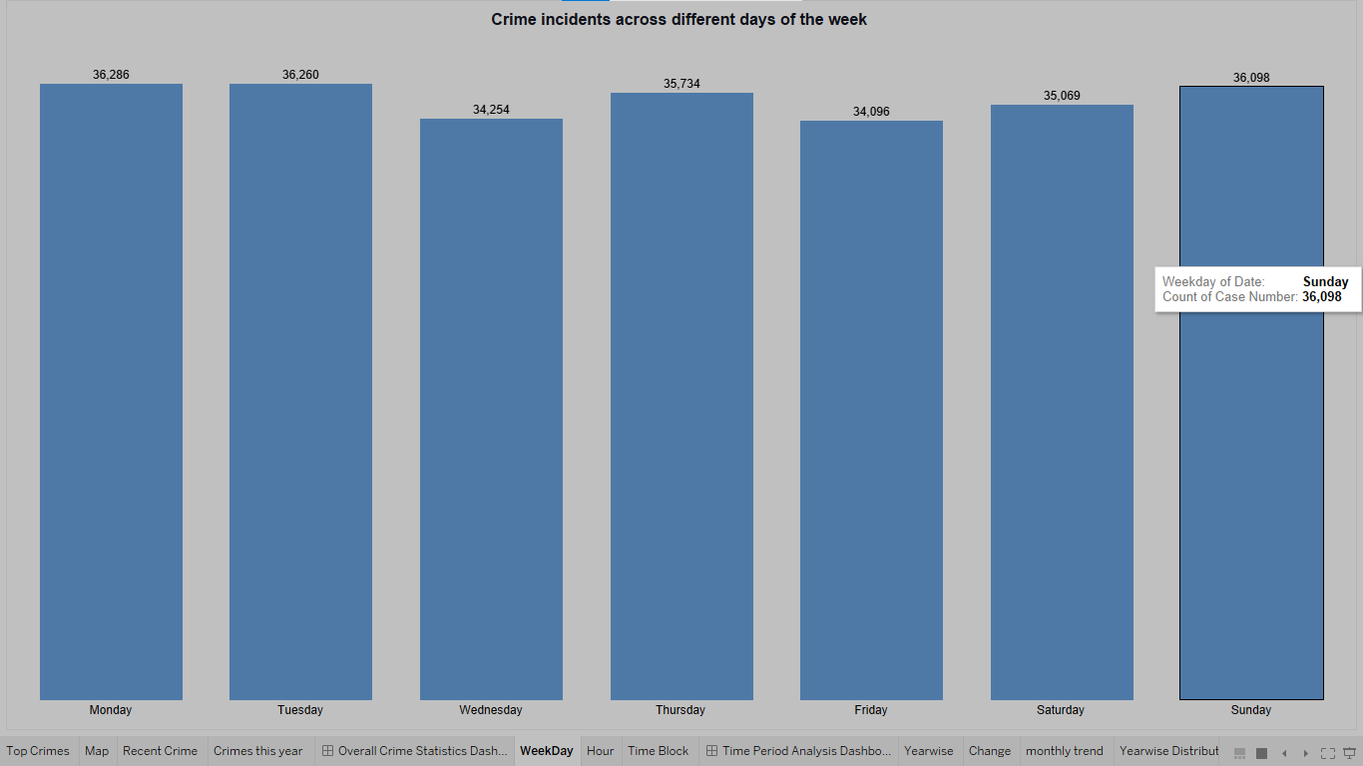

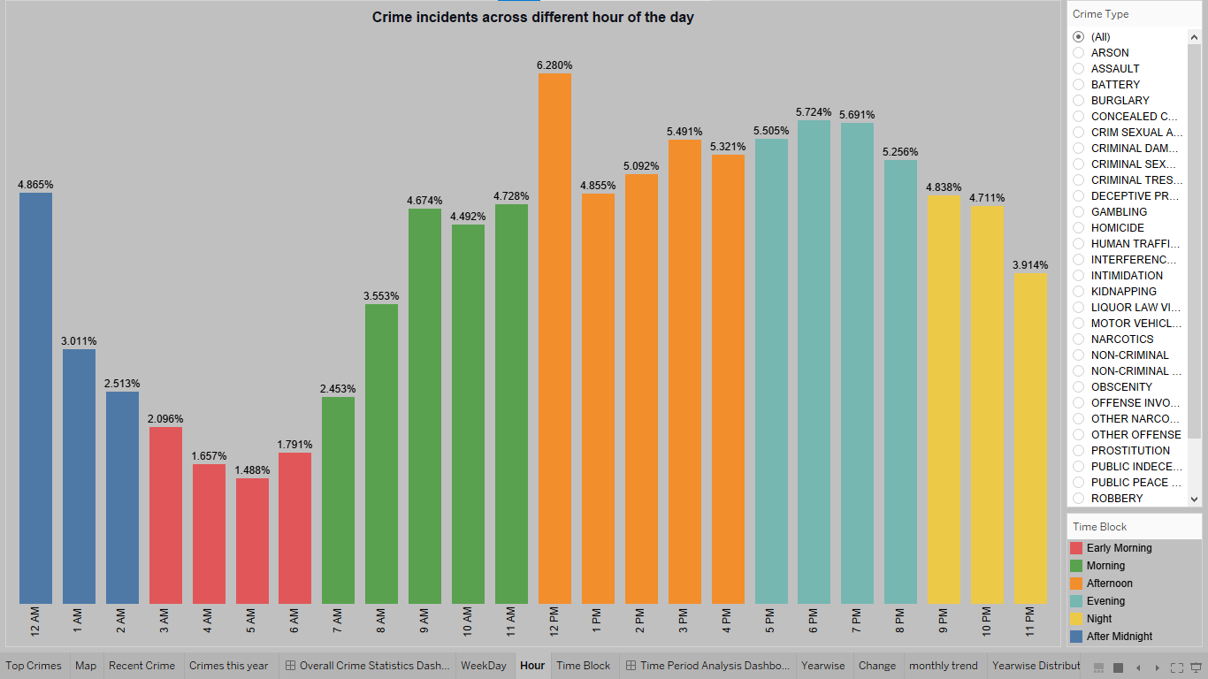

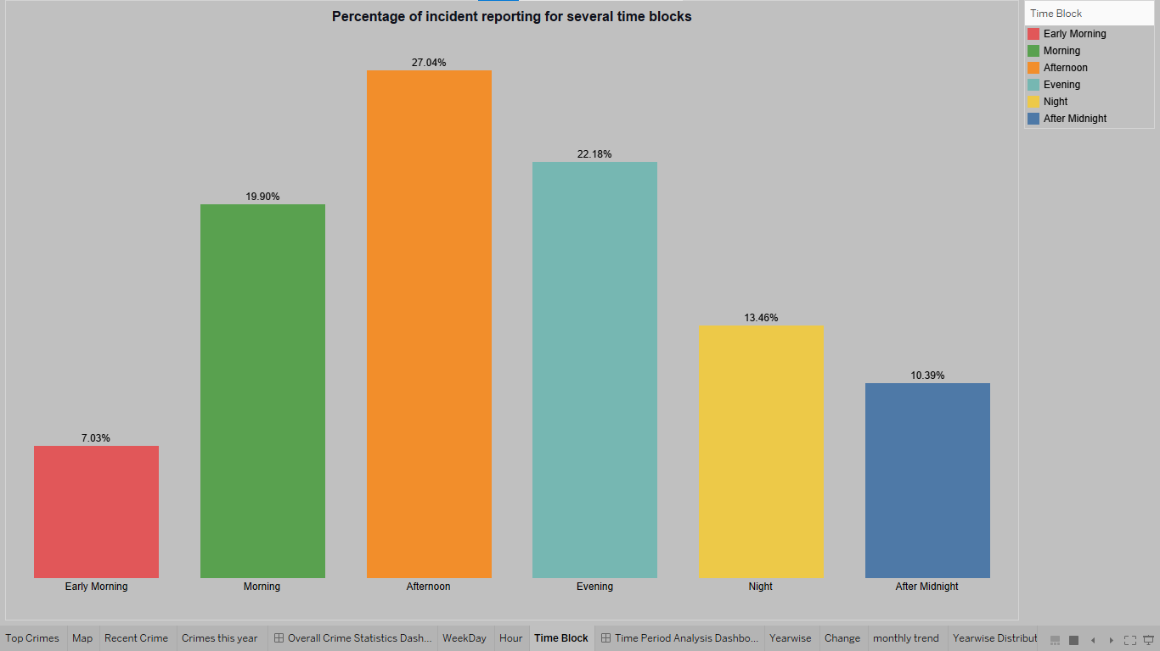

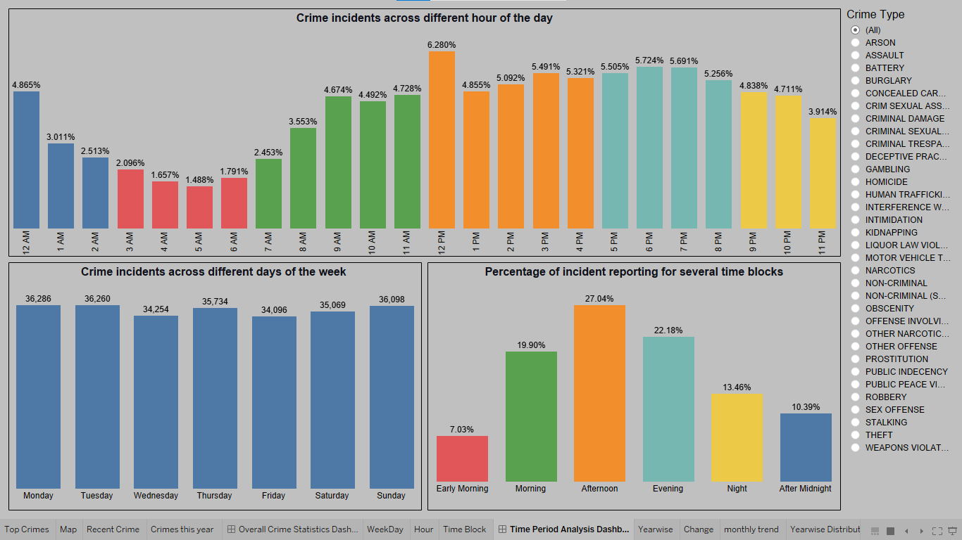

1. Trend Analysis Dashboard:
   1. Create a dashboard to study the change in crime rate over different years.
   2. Compare the change in the incident reporting over the years for the same date and time.

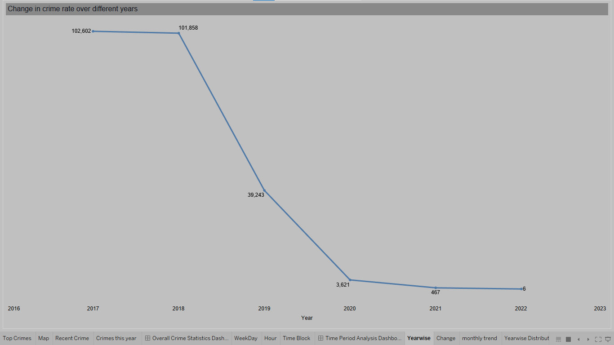

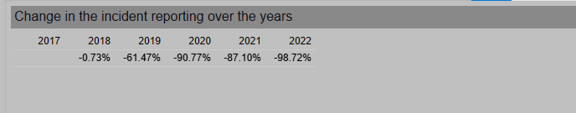

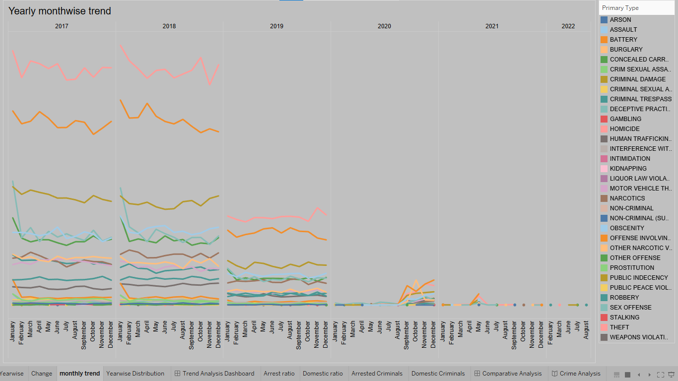

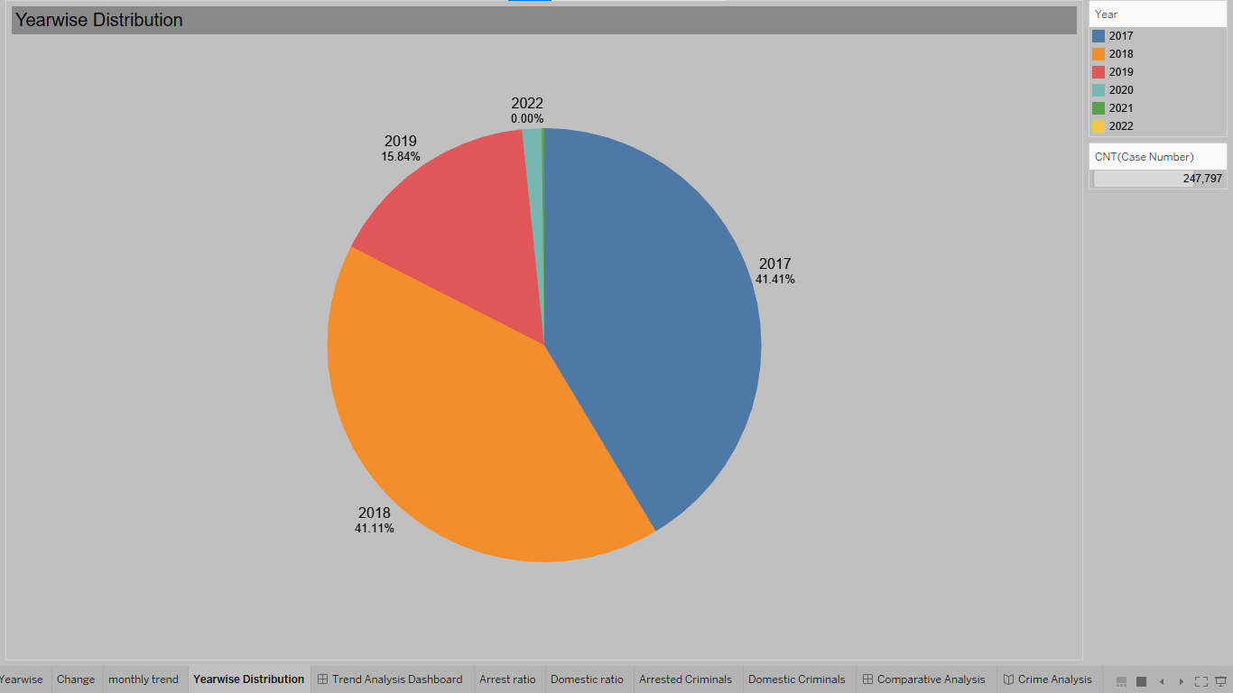

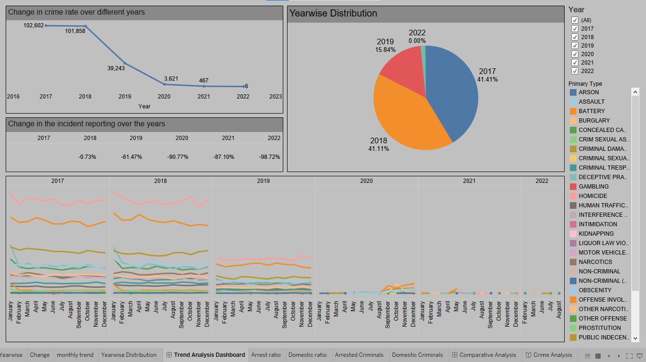

1. Comparative Analysis:
   1. Study the distribution of incidents reported where an arrest was made vs. not.
   2. Identify what percentage of the reported incidents under each incident category are domestic.

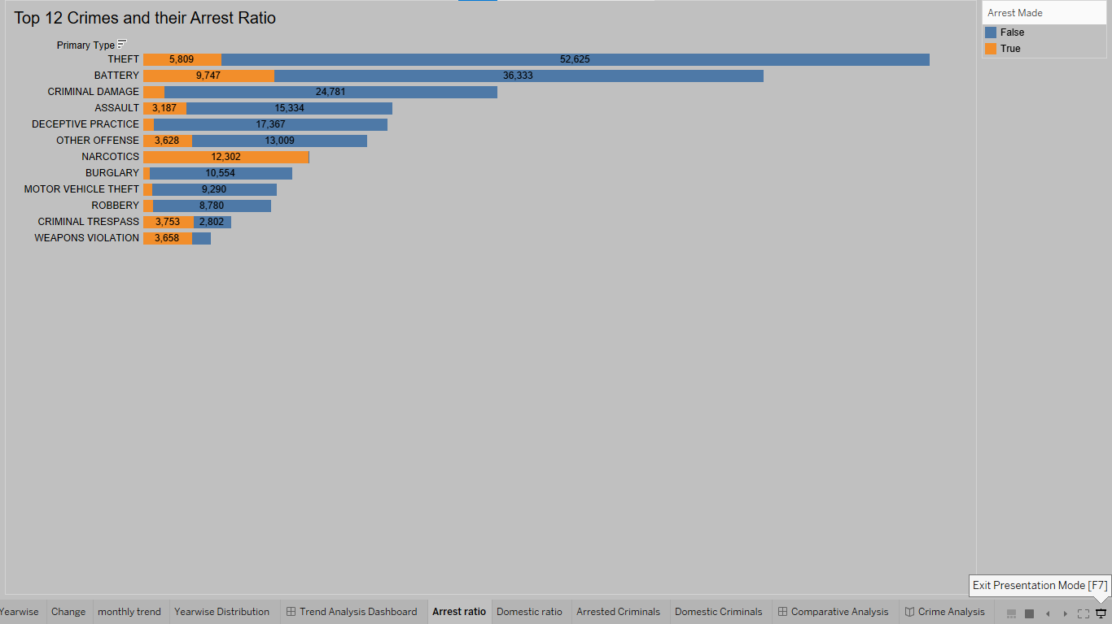

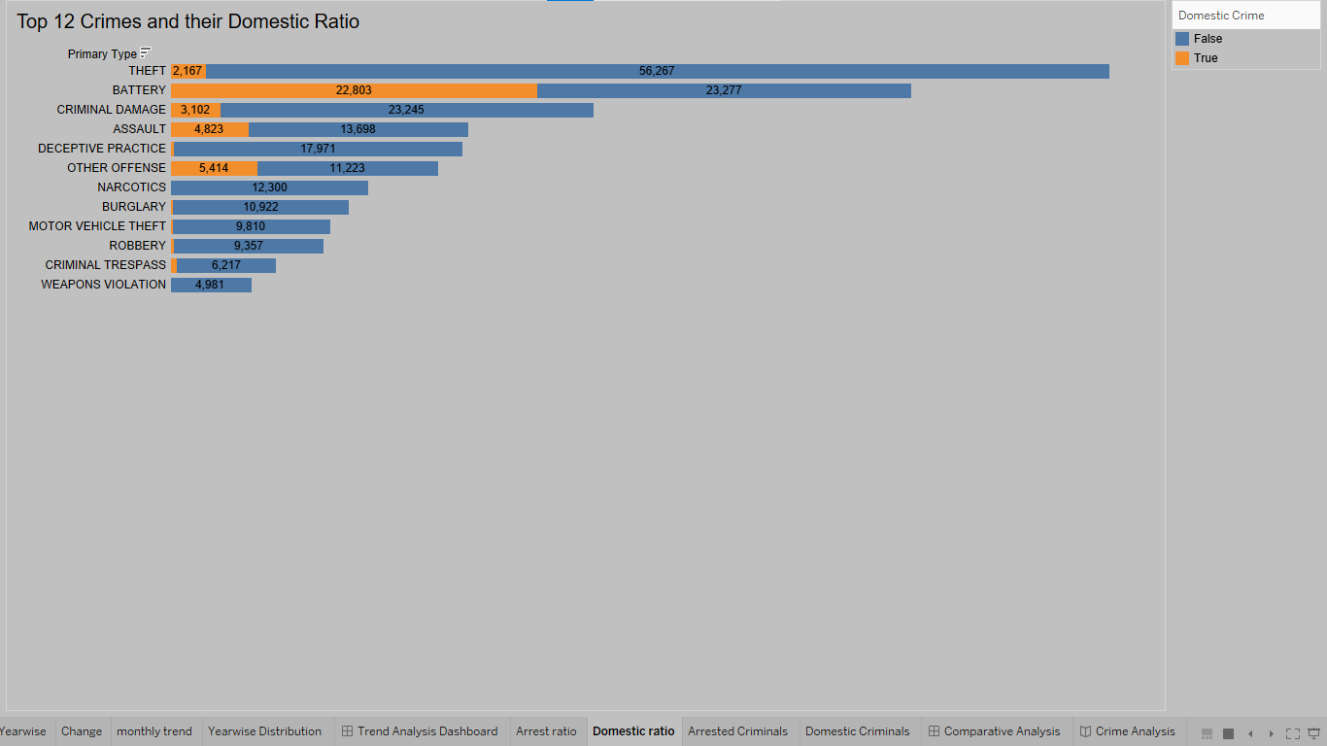

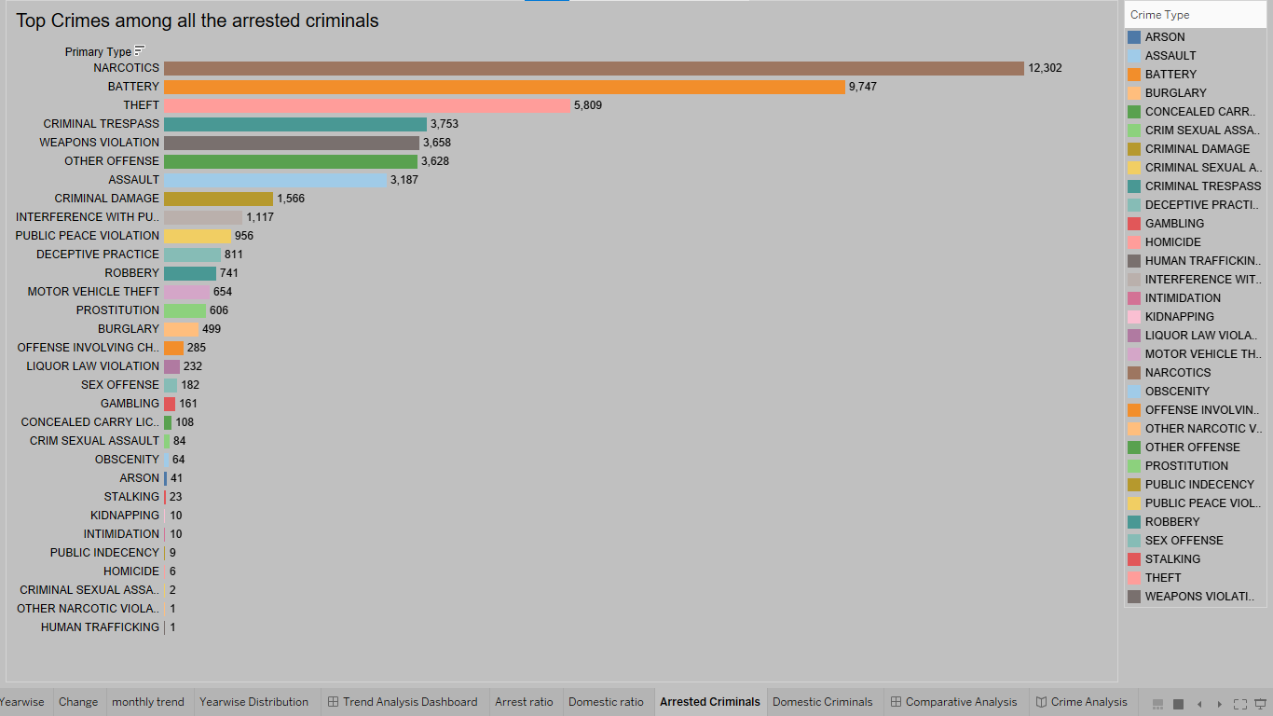

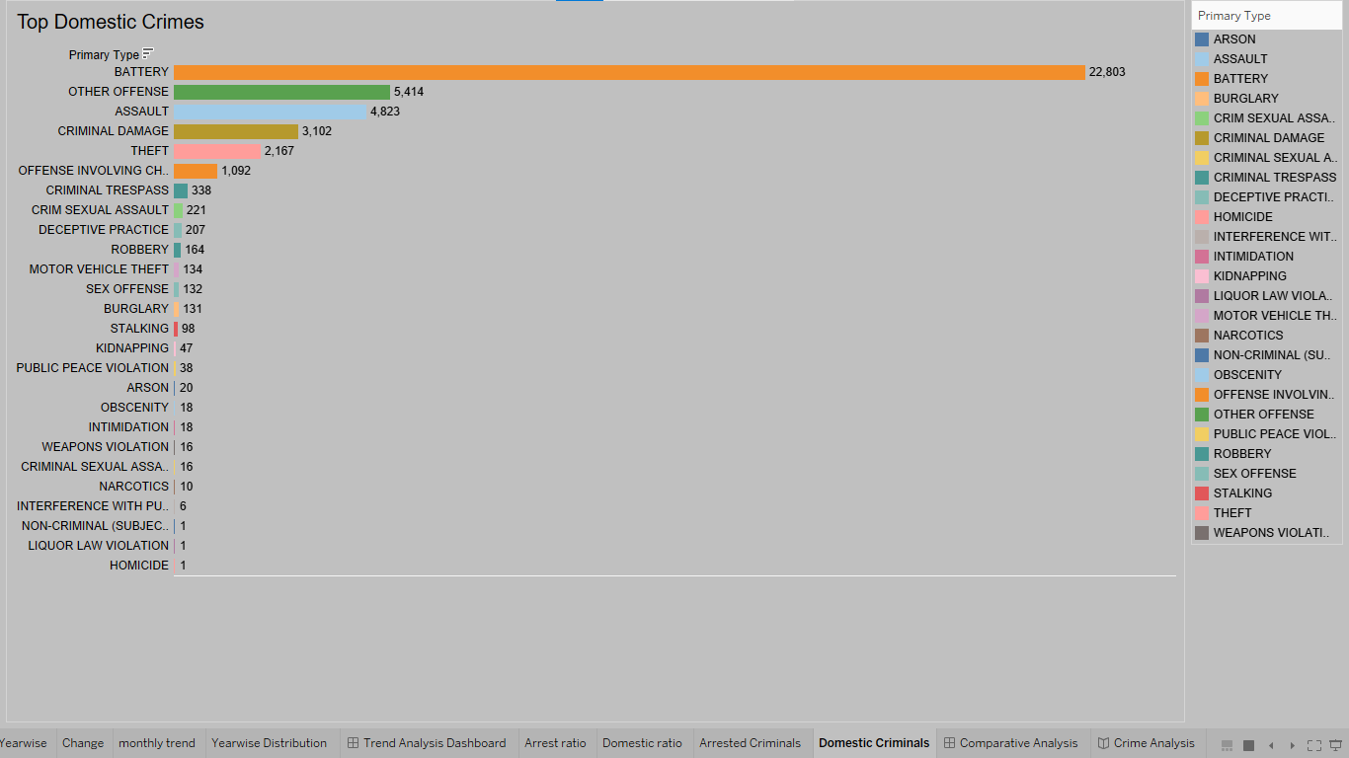

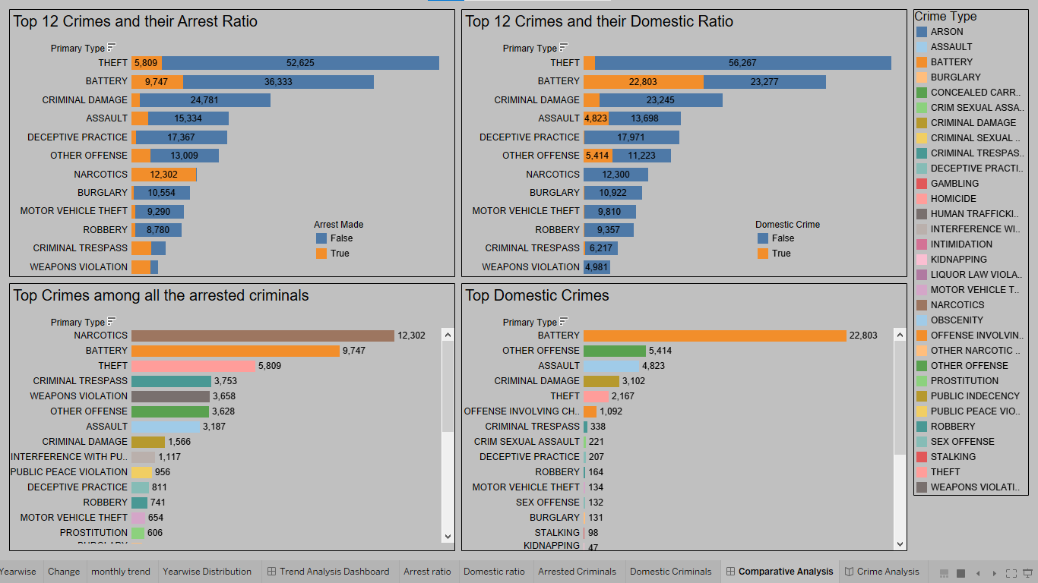

1. To make the dashboard interactive, provide filters for incident type and location in these dashboards for a granular study.

